A Green Farm
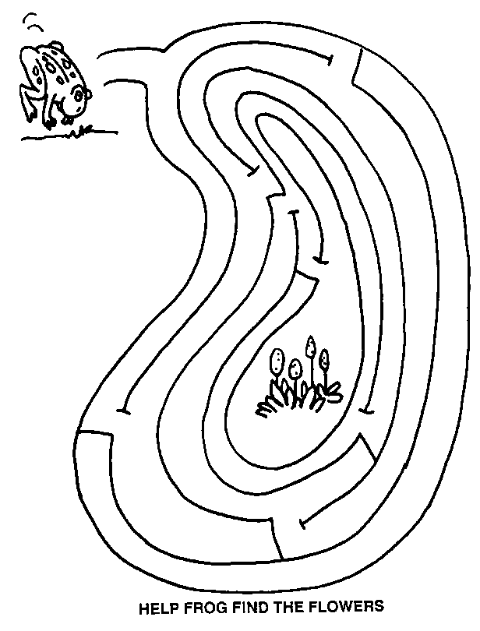

“Keep the flies away”
Working with King Conservation and King County, we found out that with a little planning and conservation you can save time and energy, which helps maintain a cleaner greener farm. Managing manure, keeping the flies and mosquitoes down, growing healthy pastures, and preventing water runoff saves money and time and protects our natural resources. King Conservation District’s program helped pay for streamside planting, fencing, gutters, down spouts, manure bins, pasture renovation, sacrifice areas, cross fencing, and restoration of native plants. Incorporating all this into the farm has contributed to the health and environment of the animals.

